All Chatbot related Components

# Queues (ChatBot related)

Supported Objects: Chat Transcript

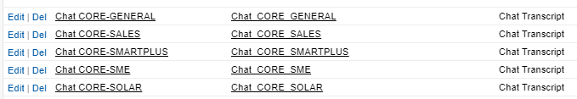

Live Chat queue for case assignment rule



# Case assignment Rule

Assign To: Live Chat



# Routing Configuration

Routing Configuration Name: Chat

Key recent changes: Push timeout, Unit/percentage of capacity

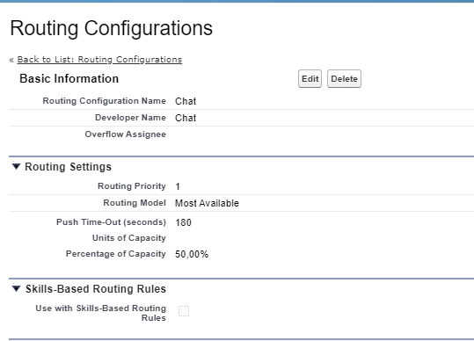

# Chat Settings

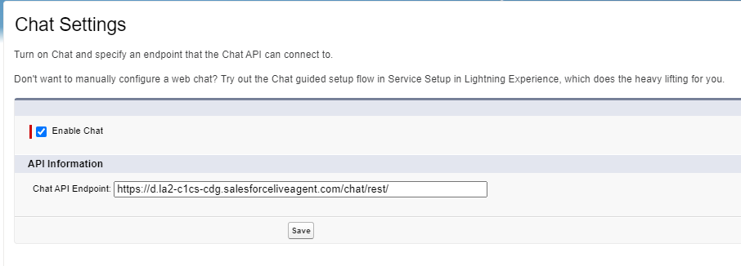

# Chat Agent Configurations

Chat Agent Configuration Name: E.on Agent

Key recent changes: Chat buttons for chat transfer setting (Overrun queues removed)

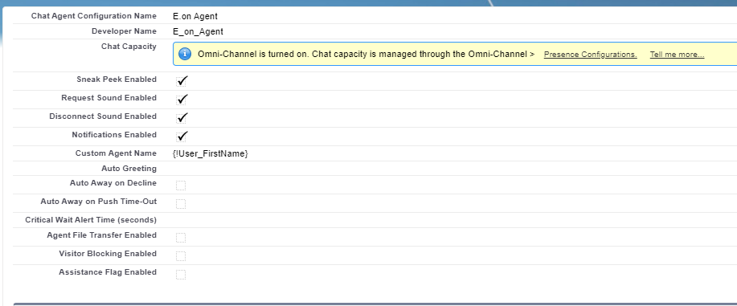

Assigned profiles : Service Agent DE, Service Agent Chat DE

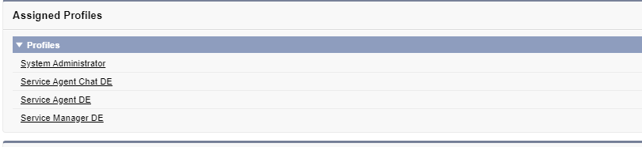

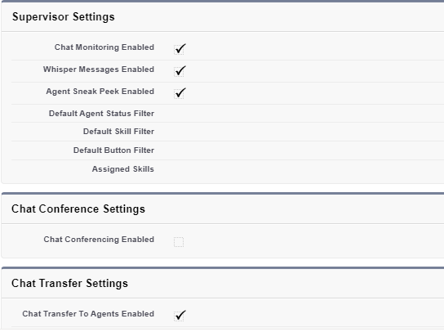

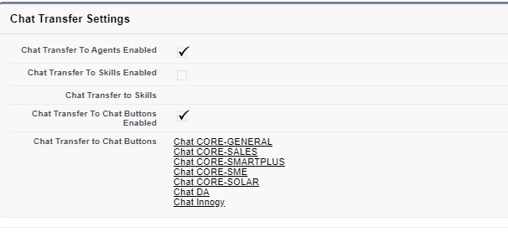

# Chat Buttons and Automated Invitations

Chat CORE-GENERAL:

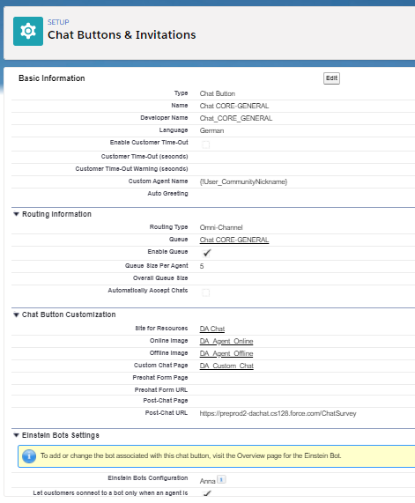

Chat Innogy:

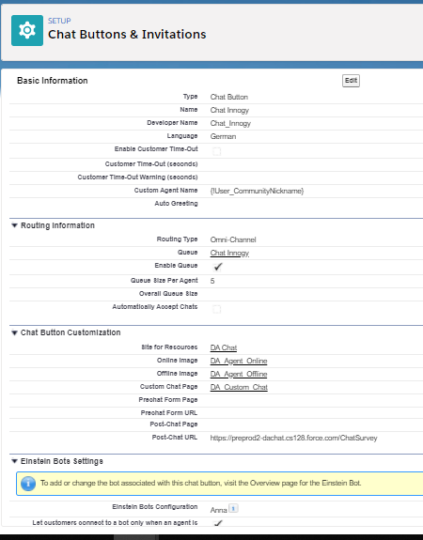

Chat CORE-SME:

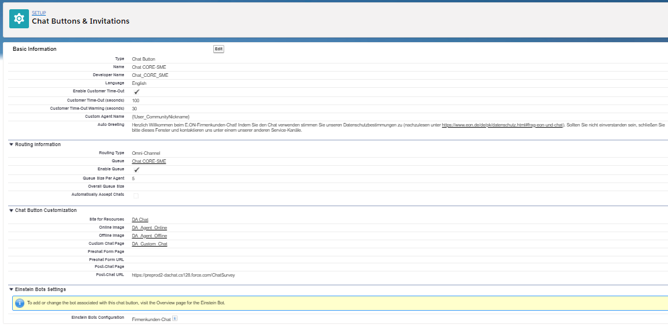

Chat CORE-SMARTPLUS

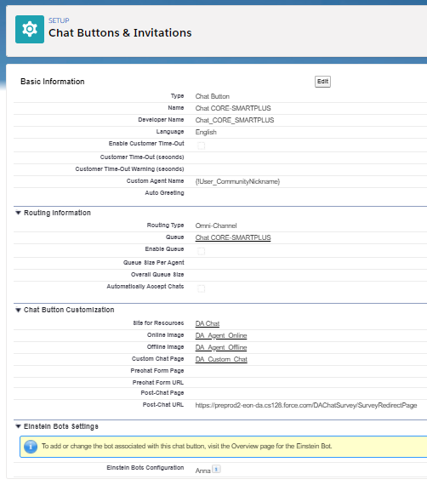

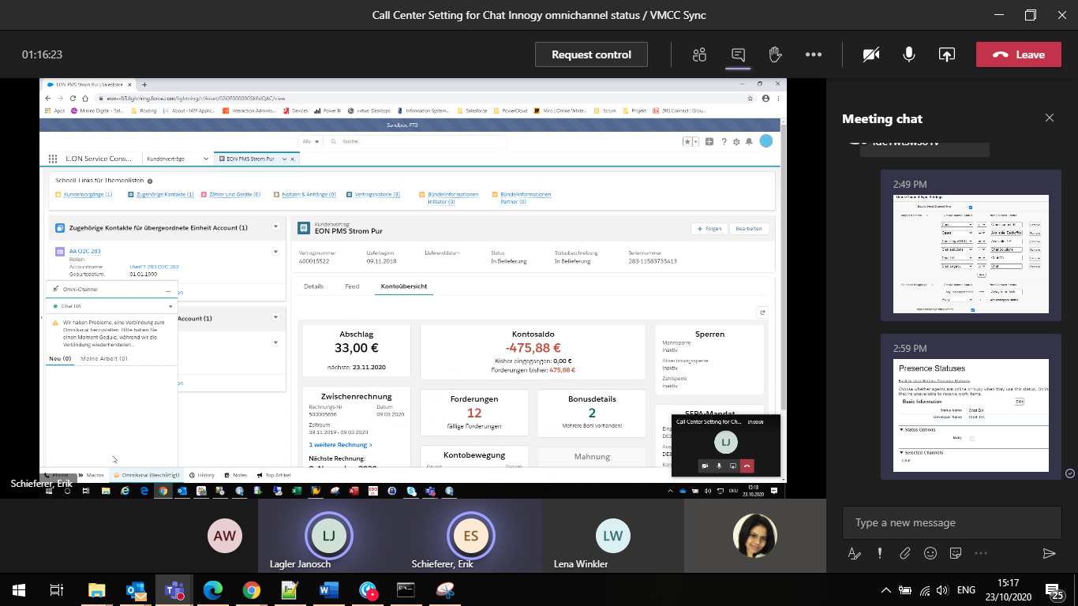

Chat CORE-SOLAR

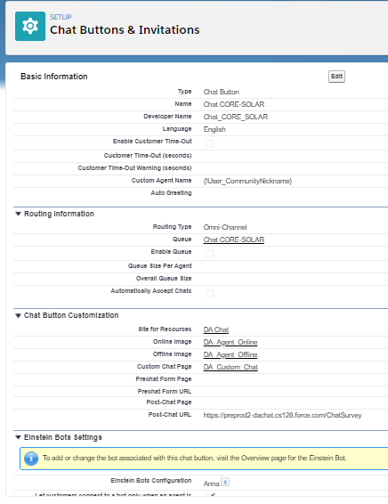

# Chat Deployments

E.on Agent

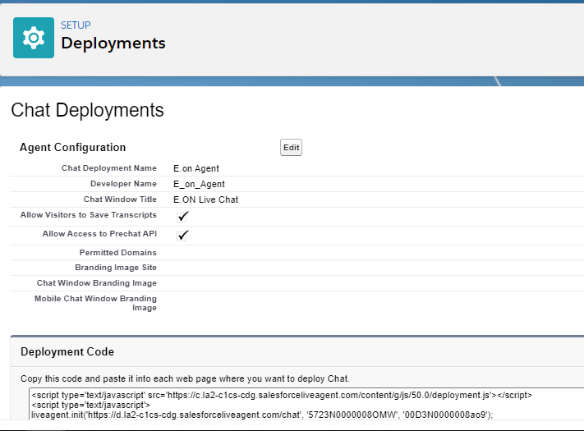

# Embedded Service Deployments

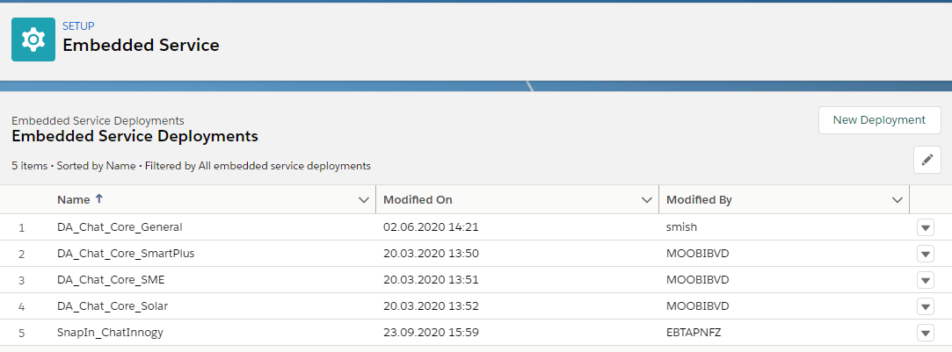

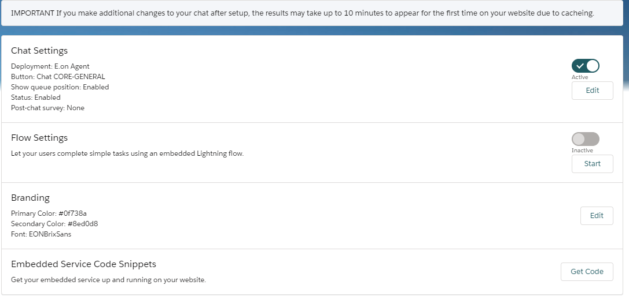

Branding Update for Chatbot

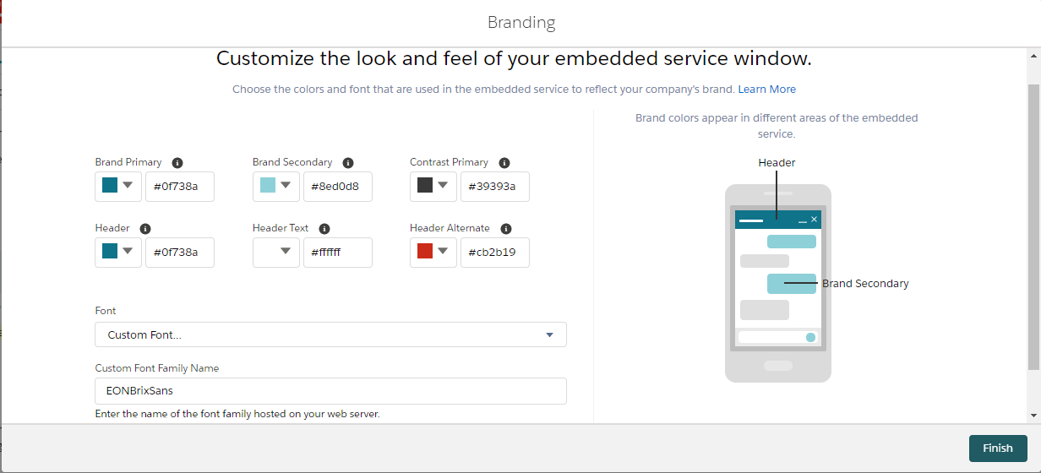

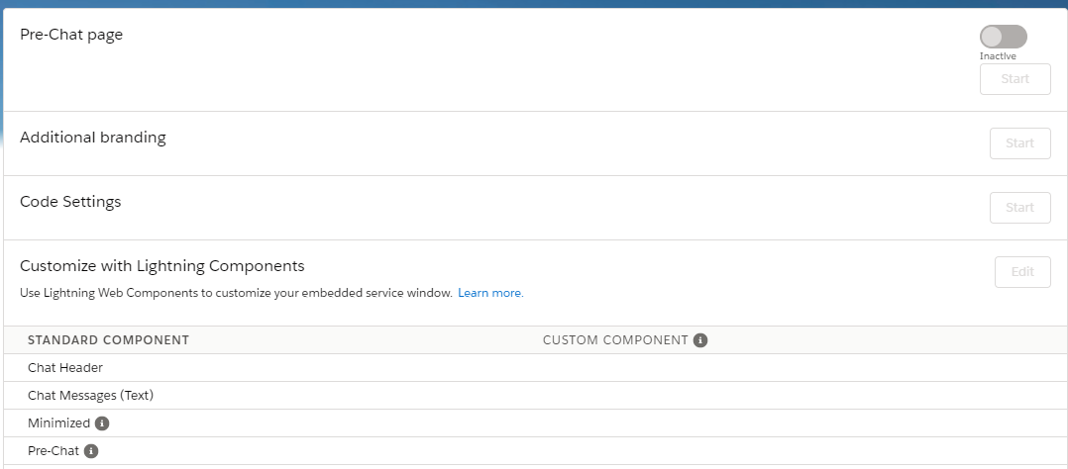

# Omni-Channel Settings

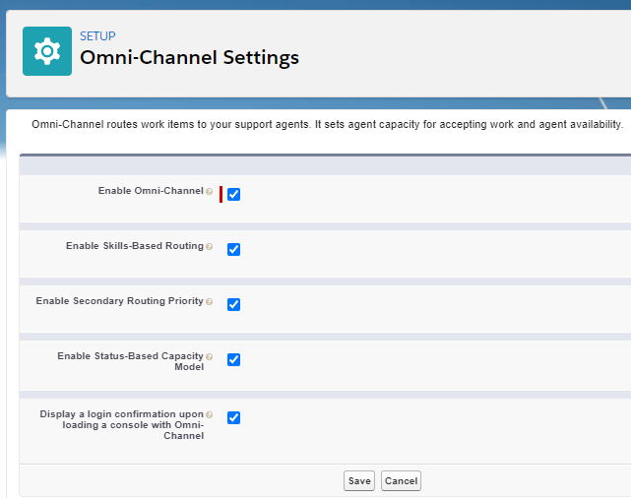

# Service Channels

Service Channel Name: Chat

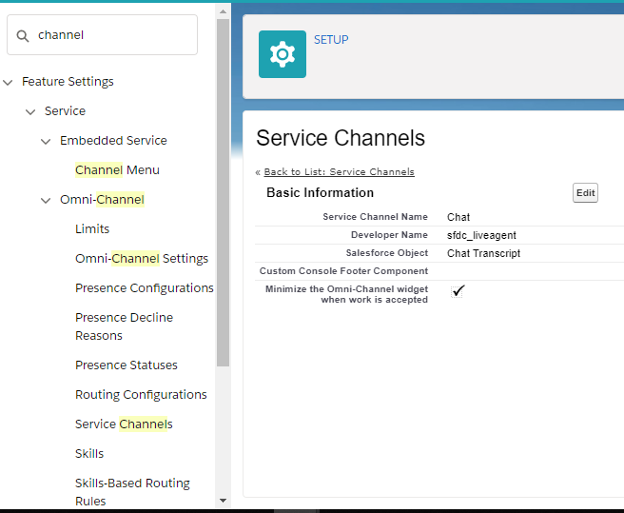

# Presence Configurations

Default Presence Configuration

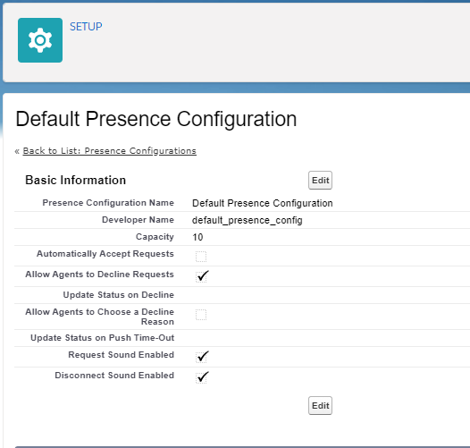

# Presence Statuses

Key recent changes: Chat Innogy status introduced

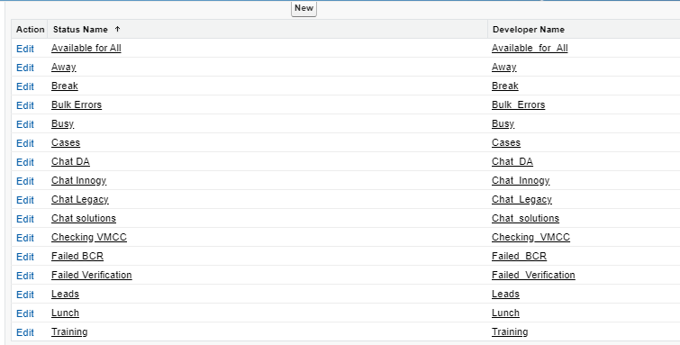

Omni-channel status sync between Salesforce and VMCC in Salesforce Call Centre Setting

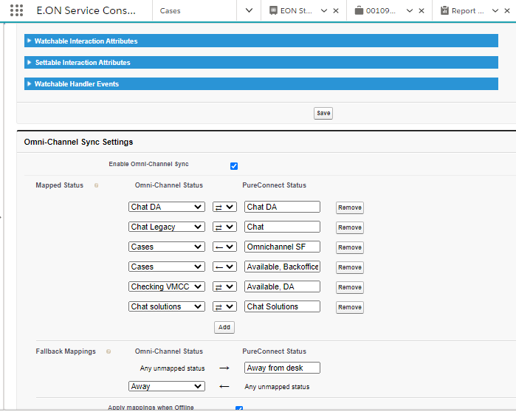

# Supervisor Setting and Configurations

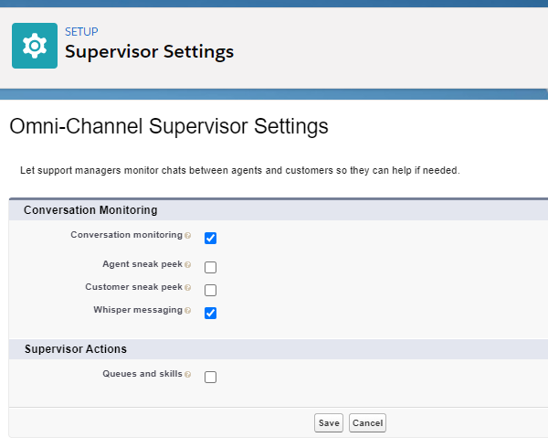

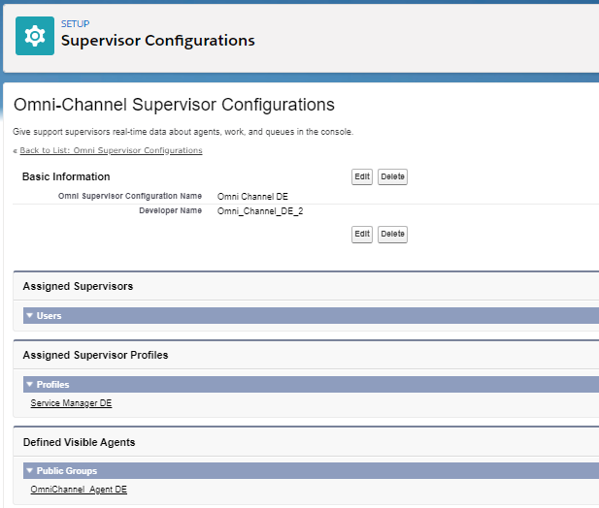

# Chatbot Survey

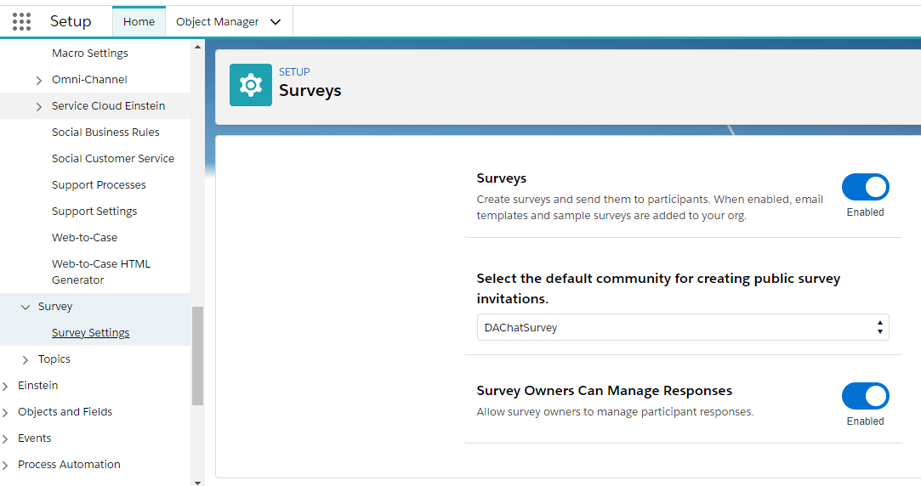

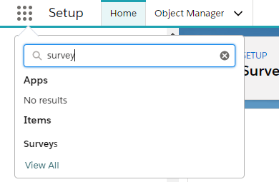

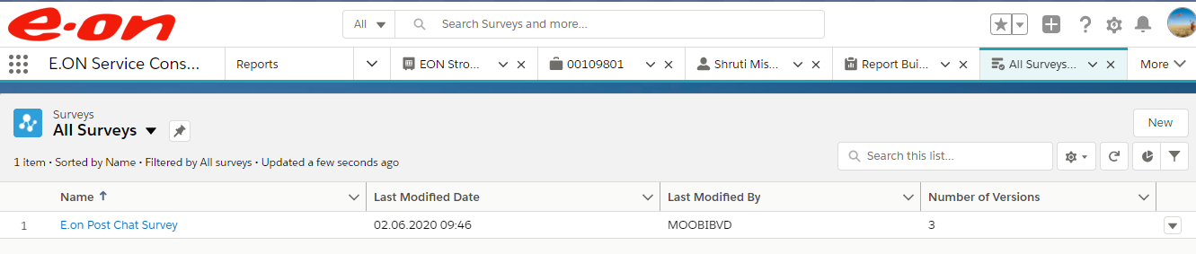

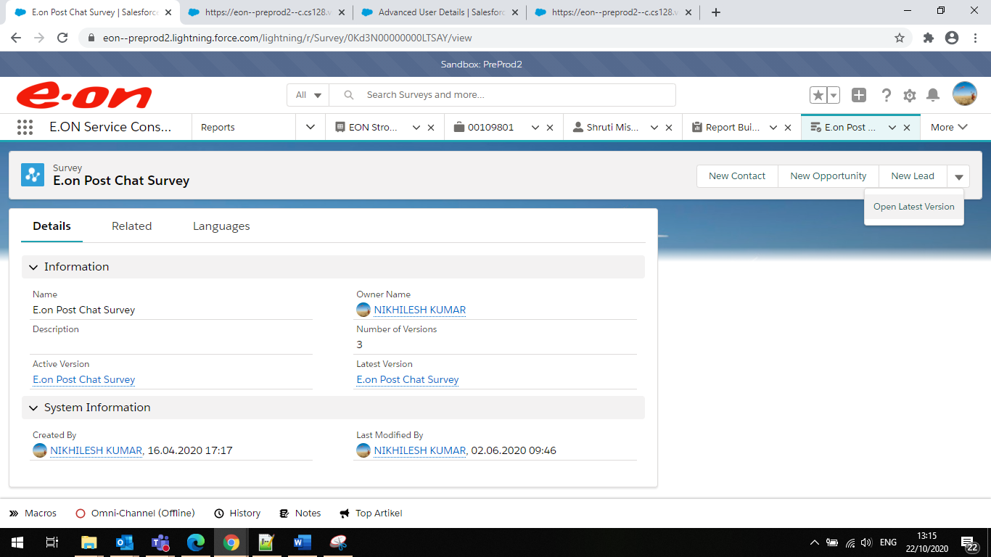

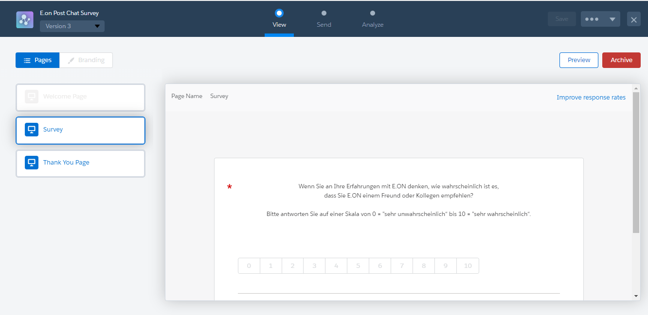

# Chatbots

Chatbot Menu option disabled:

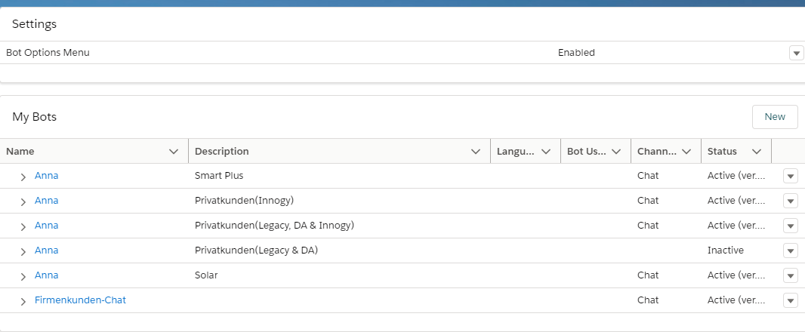

5 active Bots

* Hybrid (**Name: Anna, Description: Privatkunden(Legacy, DA & Innogy)**)
* Innogy (**Name: Anna, Description: Privatkunden(Innogy)**)
* SME (**Name: Firmenkunden-Chat**)
* SMARTPLUS (**Name: Anna, Description: Smart Plus)**
* SOLAR (**Name: Anna, Description: Solar)**

Hybrid



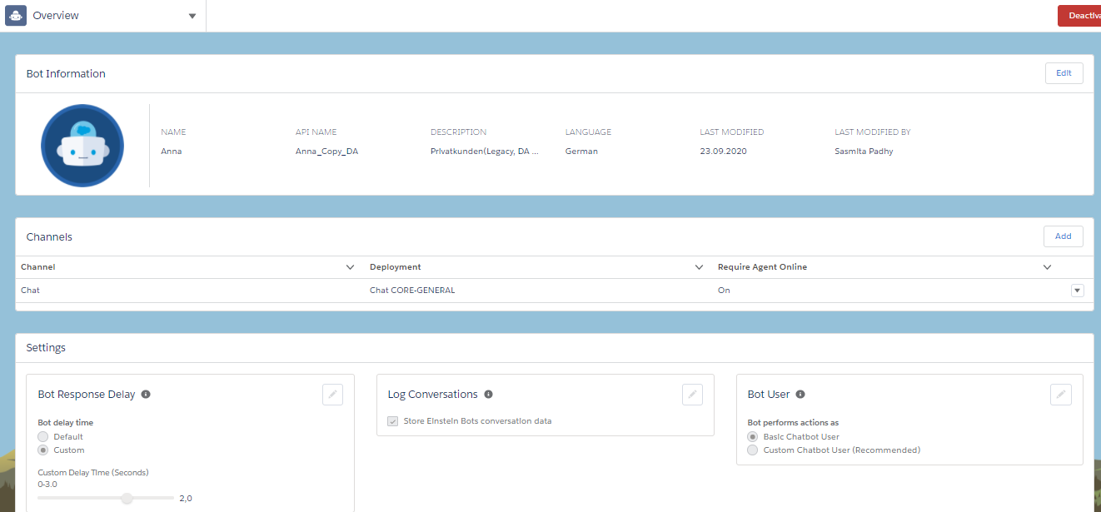

# User and Profile setting for Chatbot users

Service Cloud User and Chat User should be enabled for User using chatbot to accept work item through Chat Channel



Queues : User assigned to queue mentioned in Point 2

Permission Sets:

* sfdc.chatbot.service.permset
* LiveChat